System Details and Performance Objectives For Railway Ticket Booking Simulation

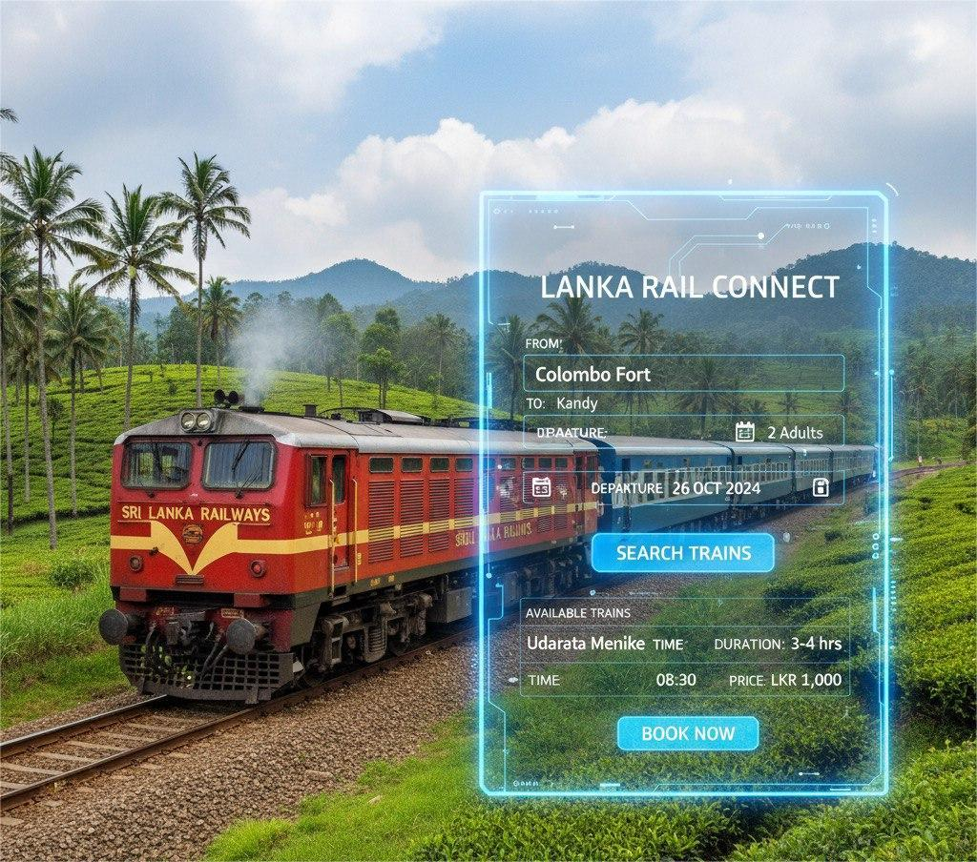

EEX5362 Performance Modelling
Deliverable 01
Name : U.S.N.Senevirathne
Registration no : 621431330

- High-Level Problem

System Name: Sri Lanka Railway Tracking and Monitoring System

Sri Lanka Railways runs several trains daily over a variety of routes that include Colombo–Kandy, Colombo–Galle, and Jaffna–Anuradhapura.

Local trains often get delayed in peak hours or in bad weather conditions, creating problems for commuters and hindering the proper utilization of railway tracks. This project covers a basic tracking system to record train timings in relation to delays, track usage, and passenger load. It helps to find out which routes or stations have delays frequently and how to improve scheduling and efficiency.

2. Dataset Description

A small dataset was created to represent daily train operations on major Sri Lankan routes.
It includes train schedules, actual departure times, and delay information.

- Train_ID : Train code or number
- Route : Train route (e.g., Colombo–Kandy)
- Departure_Station : Starting station
- Arrival_Station : Ending station
- Scheduled_Departure :Planned departure time
- Actual_Departure : Actual departure time
- Delay_Minutes :Delay duration in minutes
- Status :Whether the train was On Time or Delayed

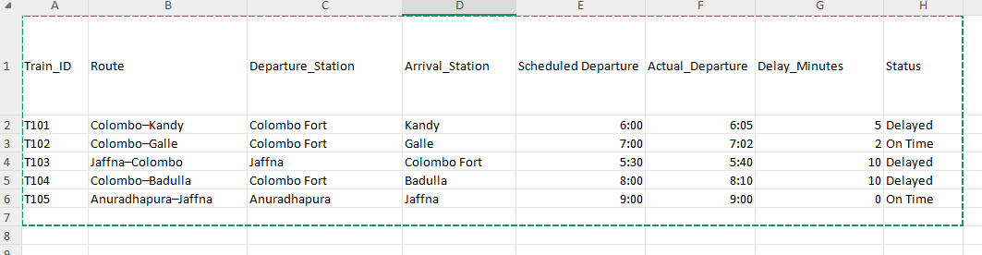

3. System Overview

The Sri Lanka Railway Tracking and Monitoring System will collect data on train timings to analyze the overall performance of railway operations. It helps in identifying delays, route efficiency, and provides insights for improvement in punctuality and scheduling accuracy.

It does this by matching scheduled departure times with the actual ones on various trains with different routes. By calculating the duration of the delay, the system will be able to highlight routes or particular trains that are always experiencing time lags, which will enable railway management to focus on problem areas like congestion, maintenance issues, or operational inefficiencies.

System Components

1. Data Collection

- The system gathers data from selected railway routes across Sri Lanka, such as Colombo–Kandy, Colombo–Galle, and Jaffna–Colombo.

- Each record provides detailed information on the Train ID, Route, Scheduled Departure, Actual Departure, and Delay in minutes.

- Data can be obtained from existing railway operation logs, timetable records, or digital monitoring tools.

2. Data Processing

- The system processes the gathered data in comparing scheduled and actual departure times.

- It then calculates the delay minutes for each train.

- Using this data, it can calculate:

- Average delay per route

- Frequency of delays

- Routes with the highest or lowest punctuality

3. Output and Analysis

- The output provides a summary report with each train's performance, indicating any delays or if the train was on time.

- Visualizations or tables can highlight:

- Average delay trends over time

- The most delayed routes

- Performance Objectives (For Railway Ticket Booking Simulation)

The main goal of the given project is to analyze and improve performance in different conditions, especially if a great number of passengers are trying to book tickets at the same time. Here, the system simulates how efficiently tickets could be allocated while minimizing delays or failures.

The following specific objectives are identified:

1. Reduce Waiting Times

Meaning: Reduce the average time a passenger waits before successfully booking a ticket.

Why it matters: Real-world systems face the problem of slow or non-responsive servers when a large number of users try to book tickets simultaneously, for example, during special trains or festivals.

Simulation aspect: The program is able to measure how much time each passenger spends booking and find ways to make it faster, such as optimizing the handling of booking requests in the queue.

2. Maximize Throughput

Meaning: Increase the total number of successful bookings completed within a given time period.

Why it matters: Higher throughput means the system can handle more users efficiently, allowing more passengers to get tickets before they sell out.

Simulation aspect: Throughput can be measured by counting how many passengers manage to book in a simulated minute or hour. It can be realized by improving algorithms or deploying several threads of processing.

3. Bottleneck Identification

Meaning: Locate bottlenecks or points in the system that result in slowdowns or failures under high loads.

Why it matters: Bottlenecks include everything from server delays and slow response times to a number of requests arriving all at once that prevent users from completing bookings.

Simulation aspect: The model helps pinpoint those points where queue length is excessively long or the attempts to book repeatedly fail, thereby showing areas where performance needs improvement.

4. Improve Resource Allocation

It means to utilize all the available booking resources, such as servers, agents, or processing threads.

Why it matters: If one booking counter/thread is serving a lot of users, while others are sitting free, then the overall efficiency decreases.

Simulation aspect: It can simulate distributing passengers evenly across several counters or servers so as to balance the load and decrease waiting time.

5. Ensure Scalability

Meaning: Assess the performance of the booking system under a sudden increase in passengers.

Why it matters: In real railway booking rushes, several thousand users might be trying to book at once. A scalable system can gracefully handle such surges in load without crashing. Simulation aspect: The project tests different levels of passenger traffic, for instance, 50, 100, 500 users, to observe changes in performance metrics with scale, like success rate and response time.

